Project: Bacteria Colonies
Difficulty: Level 3

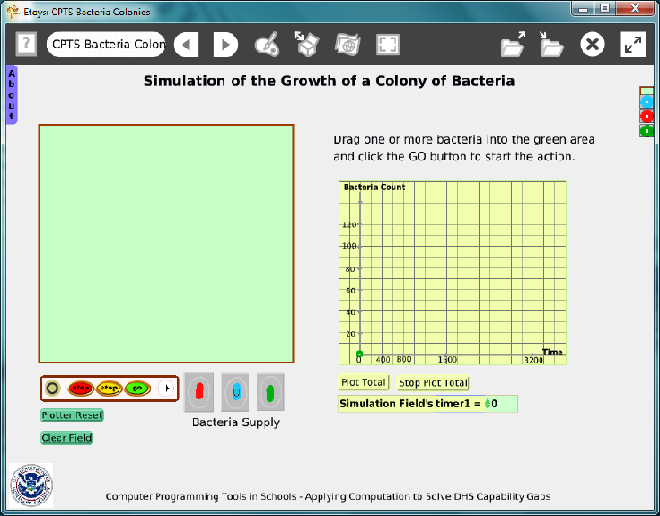

Time: Four – Six 45 minute labs

Challenge: Create an environment to show a bacteria’s life cycle. The amount of energy required to multiply or to sustain life should be a variable that can be used in a variety of simulations. Include a graph to plot the change in the number of bacteria over time.

Programming:
This project has several components and, while none of them are difficult, programming the number of objects and their scripts will take time for students to think about and then to write.
The playfield, where the simulations occur, has five variables.
The graph plots the number of each kind of bacteria over time with two scripts; one for location and the other is a reset script.
There are three types of bacteria, each with two variables and four scripts.

Things you’ll need to know:
Quick Guides
- Paint Tools/ All
- Halo Handles/All
- Supplies: Object Catalog, Text, All Scripts, Holder, Add a New Flap,
- Object Catalog: Maker Button
- Script Tiles: Forward by, Bounce, X and Y Tiles, Pen Use, Heading, Scale Factor, Hide and Show, Random Numbers, Tests Category, Two Color Tests,
- Menus: Normal Ticking, Viewer Icons Set, Scriptor Icons Set, Button Fires a Script, Watchers, Playfield Graph Paper
- Create variables by clicking on the V in the top of a Viewer.

Things to think about:
- Changing the conditions controlled by the variables will generate graphs that can be compared. Use a grab patch tool to keep copies of graphs.

Extensions:
- Add variables for temperature or ph factor.

NETS for Students:
http://www.iste.org/standards/nets-for-students/nets-student-standards-2007.aspx
1. Creativity and Innovation: a, b, c, d
3. Research and Information Fluency: a, b, c, d
4. Critical Thinking, Problem Solving, and Decision Making: a, b, c
6. Technology Operations and Concepts: a, b, d

CSTA:
CSTA Level II: Objectives and Outline
http://csta.acm.org/Curriculum/sub/CurrFiles/L2-Objectives-and-Outlines.pdf
Level II objectives for middle school students are furthered through studying a programming language well enough that the student is proficient with it. Whether the language is Etoys, StarLogo TNG, or Scratch, it is the ability to use the language to express ideas that is valuable. A student skillful enough to use any programming language to express ideas, solve problems, model behaviors, simulate data, or to educate or entertain is an entitled person in today’s society.
Topics of particular note are:
Topic 2: Problem Solving
Topic 6: Connections between Mathematics and Computer Science
Topic 11: Programming Languages
Topic 13: Multimedia

Common Core Standards Mathematics:
http://www.corestandards.org/the-standards/mathematics
6. EE.2, 6.EE.6, 6.EE.9
7. SP.6, 7.SP.7, 7.SP.8
8. EE.5, 8.EE.8c, 8.F.1, 8.F.4, 8.F.5

Teacher Notes:
Materials: Give students time to research information about specific kinds of bacteria, perhaps ones that are in the news frequently such as Lisiteria, or Salmonella.
www.dhs.gov The U.S. Department of Homeland Security includes informational links about food safety and supply infrastructure. For example: http://blog.dhs.gov/2010/11/thanksgiving-safety-tips-from-us-fire.html

www.fda.gov The U.S. Food and Drug Administration web site lists recalls and safety alerts

Comments: Objects - Scripts – Decisions
Teacher Notes for Etoys Bacteria Applet in Math Class

If all aspects of this project are done it could take as much as 5 class periods:

Days 1 and 2 Student Handout

The handout that follows is intended to have students critically watch the behaviors of the various bacteria in the Etoys applet. After watching, they are asked to analyze what they are observing and compare that to what a plot of the data is showing. There will be no wrong or right answers per se, but certain trends should appear and students should be able to defend their responses.

Thoughts on the questions:

1) It is possible that a single bacterium may die before splitting, but barring that, they will split.

2) Students should note that overall the bacteria seem to be growing in number, but there are times when the actual number on the playfield is less one second that it was the second before. So a conversation of “strictly” increasing could take place. The answer to the question about “increasing constantly” could be argued to be either true or false, depending on what you call “constantly”. (i.e. for no prolonged period is the number decreasing), but then again “constantly” could imply a constant slope which means the graph would need to be a line. This could lead to some very interesting discussions when the class comes back together to discuss their results. Vocabulary is so important in mathematics and we often do not help our students understand that by intentionally calling it to their attention. They might even say the question was “poorly worded” and then you can agree, and ask them to reword it.

3) It appears that it could be infinite, but if “bumping into each other” is a factor, then, they will run out of room. There could be some very good conversations about what “infinite” means. There might also be some good conversations about “rate” of growth and whether that means in can’t be infinite.

4) The discussion of the graphs might vary widely, but exponential or logarithmic might come into play. Some might even mention polynomial and that could lead to some good conversations about what “degree” the polynomial would have to be!

5) Answers will vary, but “size” should enter the conversation. Note: In the flap “about” it talks about how the bacteria grow and die. I assume that the students will not look in the flap if I do not mention it, but if they do read the flap, they will still need to describe in their own words what they “observe”. You can also “hide” the flap if you want to make sure they don’t see it.

6) See # 2 above.

7) See #3 above.

8) See #4 above.

9) Answers here will vary widely. It is mainly here that the whole class discussion takes place. You should have a list of things you especially want to emphasis (be it related to the math, to vocabulary, to functions, to graphs, or to observation methods in general) and make sure to bring your list into the conversation if the students fail to mention items on it.

The basic behavior of the bacterium can be explained by looking in the “About” flap. You will need to see the rates at which they gain and lose energy. You can remove the “About” flap from the project before giving it to your students by getting its halo and hitting the X.

10) Color should come into the conversation. Other than that the behavior is the same.

11) Color is the indicator.

12) Red will always win. The growth rate is the key.

Days 3, 4, & 5 Remixing the Etoys App
When all the questions have been answered, you can turn your attention to the programming if you wish. You can take students through the scripts and “dissect” them to see where and how the actual behavior of the bacteria was accomplished. You could then assign groups of students a particular type of bacteria to research (how do they grow, divide, die, etc) and then have them build their own Etoys app to model the behavior.

Example Scripts:

Playfield

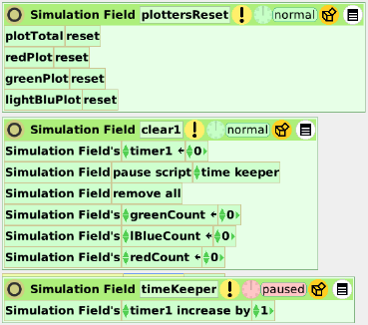

Bacteria
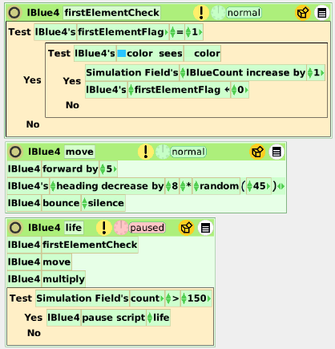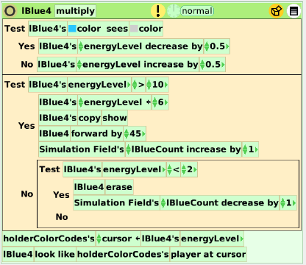

Student Notes:
Bacteria Simulation Investigations: Observations Name __________________

Bacteria are microorganisms that can multiply. They are present everywhere and have both positive and negative effects. This app allows you to see how bacteria can grow (or decrease) in number and size. For this activity you will play around with the app and make some observations about what you see happening. These are just observations, so what you perceive may be different from what others perceive. You can stop the application, clear the playfield and restart as many times as you want.

I Take a single green bacterium and drop it in the “playfield”. Click the “go” button and just watch.
After you begin to see what is happening, answer the questions below.

1) Does a bacterium always split itself? Explain.

2) Does the number of bacteria increase constantly? Explain.

3) Over a long period of time how many bacteria do you think there might be? Explain.

4) Clear the playfield and reset the plotter. Drop one green bacterium in the playfield, click go and let the timer run to 800. Sketch below the graph you get.
What does the graph tell you? Make at least 3 observations.

1)
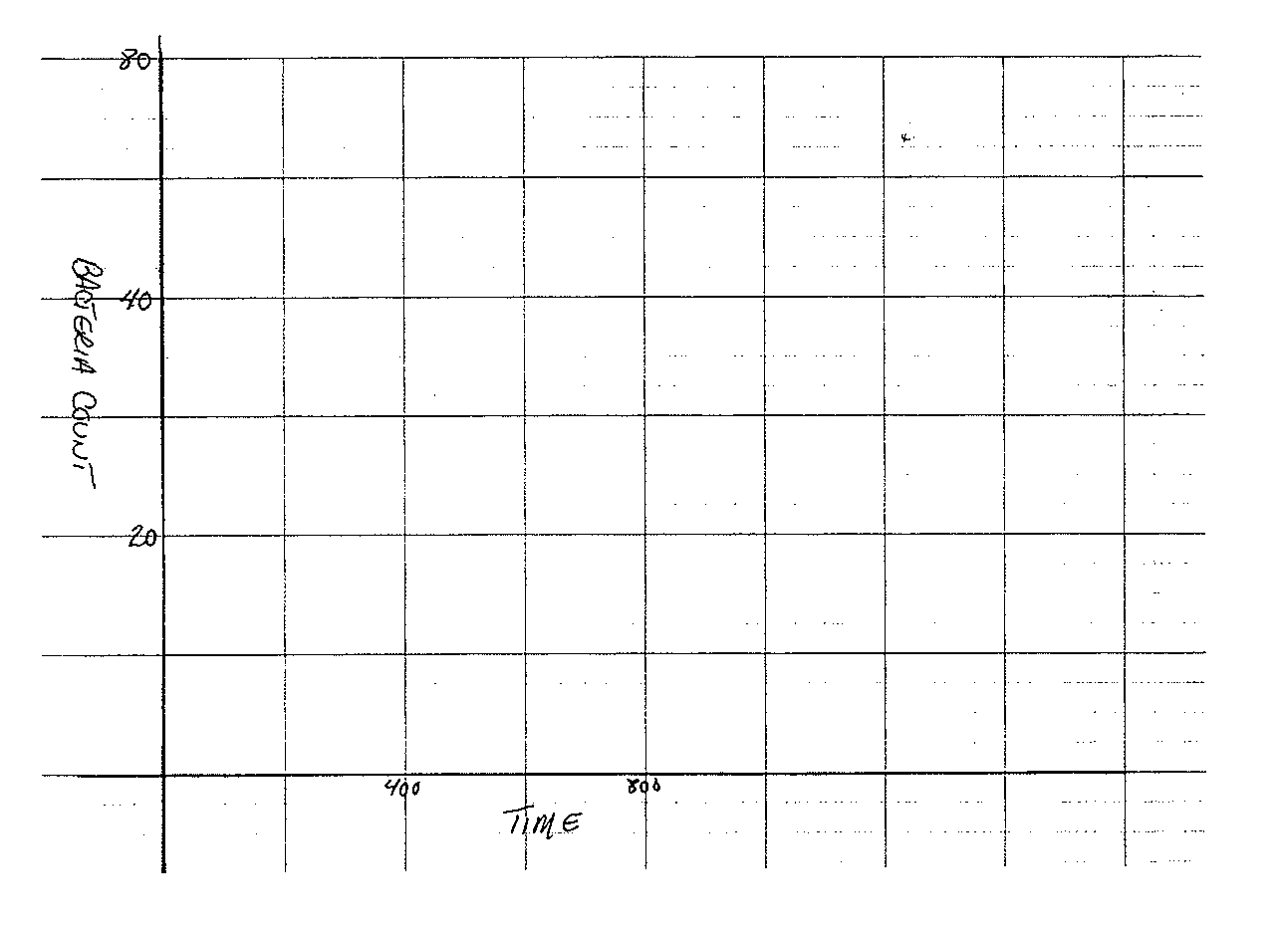

2)

3)

II. Take a single red bacterium and drop it in the “playfield”. Click the “go” button and just watch.
After you begin to see what is happening, answer the questions below.

5) Does a red bacterium act the same as a green bacterium? Explain.

6) Does the number of red bacteria increase constantly? Explain.

7) Over a long period of time how many red bacteria do you think there
might be?

8) Clear the playfield and reset the plotter. Drop one red bacterium in the
playfield, click go, and let the timer run to 800.
Sketch below the graph you get.
What does the graph tell you? Make at least 3 observations.
1)

2)

3)

9) Try to explain what you think the rules might be for why the red bacteria
behave the way they do.

III. Clear the playfield and reset the plotter. Drop one blue bacterium in the playfield, click go and just watch.

10) How does the behavior of the blue bacteria differ from that of the red
and green bacteria?

11) How can you predict when a blue bacterium will split or die away?

IV. Clear the playfield and reset the plotter. Drop one of each color bacterium in the playfield, click go and just watch.

12) List below any behaviors you observe as the bacteria interact with each
other. If you think you know why the behaviors are occurring, indicate
the reasons as well.

